06.03.2020

Contact specialized press
Thomas Lange
Phone +49 201 173-3050
thomas.lange2@evonik.com

Evonik Resource Efficiency GmbH
Rellinghauser Straße 1-11
45128 Essen
Phone +49 201 177-01
Fax +49 201 177-3475
www.evonik.com

Supervisory Board
Dr. Harald Schwager, Chairman

Executive Board
Dr. Claus Rettig, Chairman
Andreas Fischer,
Simone Hildmann,
Alexandra Schwarz

Registered Office: Essen
Register Court: Essen Local Court
Commercial Registry B 25783
VAT ID no. DE 815528487
Can anything be done about snail trails? A new additive will help.

- ZEOFREE® 600 prevents snail trails – right from the start
- Economic and effective

Your house wall is freshly painted, the facade radiates a brilliant shine – but what’s that? Highly visible vertical streaks spoiling the appearance. It’s obvious to the experts that those are snail trails! Although this initially sounds like a problem exclusive to gardeners, it is in fact a common issue for nearly all architectural coatings.

These “snail trails” typically emerge after the first bout of rain hits the building wall. The rain washes water-soluble components, such as additives or emulsifiers, out of the paint. These washed-out materials run down the wall, leaving behind unsightly streaks, also known as snail trails.

To date, facade paint manufacturers have tried to prevent snail trails by carefully selecting the ingredients for their formulation. Some dispersing agents and binders feature a significantly reduced tendency towards snail trails, although this can cause new problems. The new significantly restricted choice of ingredients means that formulators need to carefully coordinate the components – and pay more for these than for the standard versions.

The Coating Additives business line of Evonik takes an entirely different route to eliminating those annoying snail trails: The novel ZEOFREE® 600 additive, when added to coatings during or post-formulation, stops snail trails from arising in the first place. The powder additive consists of a calcium silicate with a particularly porous structure. The fine particles of ZEOFREE® 600 work like a sponge – they absorb and retain the water-soluble components. Now if a downpour hits the house wall, the rain doesn’t wash out any material – and the facade stays just as attractive as when freshly painted.

The new additive is patent protected and is currently unique on the market. Its high oil absorption has been proven in tests according to the industry standard ASTM D 7190-10, as well as in-house rain-simulation tests. A further benefit is that the new additive is non-hazardous and meets the criteria for the EU Ecolabel 2014/312/EU.

ZEOFREE® 600 works for all non-gloss paints, from white to dark shades. The recommended addition level ranges from one to five percent depending on the formulation. Not only is this an effective solution to snail trails, it is also a cost-effective alternative to the approaches used to date.

You can find technical and safety data sheets on ZEOFREE® 600 at www.coating-additives.com.

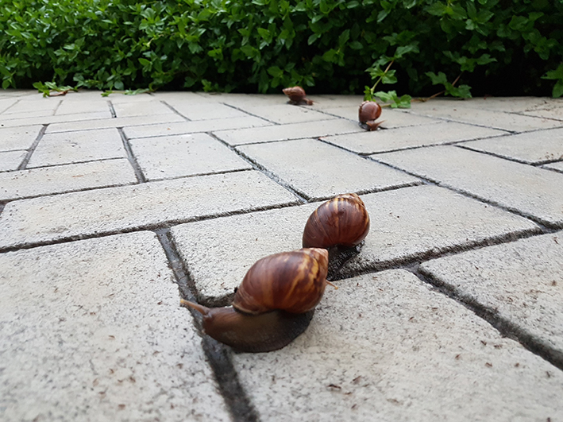

Company information
Evonik is one of the world leaders in specialty chemicals. The company is active in more than 100 countries around the world and generated sales of €13.1 billion and an operating profit (adjusted EBITDA) of €2.15 billion in 2019. Evonik goes far beyond chemistry to create innovative, profitable and sustainable solutions for customers. More than 32,000 employees work together for a common purpose: We want to improve life, day by day.

About Resource Efficiency
The Resource Efficiency segment is led by Evonik Resource Efficiency GmbH and produces high performance materials and specialty additives for environmentally friendly as well as energy-efficient systems to the automotive, paints & coatings, adhesives, construction, and many other industries. This segment employed about 10,000 employees, and generated sales of around €5.7 billion in 2019 from continuing operations.

Disclaimer
In so far as forecasts or expectations are expressed in this press release or where our statements concern the future, these forecasts, expectations or statements may involve known or unknown risks and uncertainties. Actual results or developments may vary, depending on changes in the operating environment. Neither Evonik Industries AG nor its group companies assume an obligation to update the forecasts, expectations or statements contained in this release.

