12.03.2020

Contact specialized press
Thomas Lange
Phone +49 201 173-3050
thomas.lange2@evonik.com

Evonik Resource Efficiency GmbH
Rellinghauser Straße 1-11
45128 Essen
Phone +49 201 177-01
Fax +49 201 177-3475
www.evonik.com

Supervisory Board
Dr. Harald Schwager, Chairman

Executive Board
Dr. Claus Rettig, Chairman
Andreas Fischer,
Simone Hildmann,
Alexandra Schwarz

Registered Office: Essen
Register Court: Essen Local Court
Commercial Registry B 25783
VAT ID no. DE 815528487
SPHERILEX® – A novel synthetic silica engineered for improved durability and burnish resistance

In paints and coatings, precipitated silica is widely known as a superior matting agent. Its functional characteristics, however, are eventually determined by many differentiators like particle size, size distribution, particle morphology, and more. In other words: to control these aspects means to control the properties and benefits of the precipitated silica.

The Coating Additives business line of Evonik now introduces its SPHERILEX® silica wet chemistry technology. The manufacturing process produces material with a unique spherical particle morphology, providing non-traditional silica benefits to coatings. Variations in the wet reaction process conditions allow to control many aspects of the final product, such as pH, surface area, pore volume, and other structural or morphological effects.

As a result of this technology, Evonik introduces three new products for paints and coatings: SPHERILEX® DP-0111, SPHERILEX® DP-0112, and SPHERILEX® DP-0115.

In modern architectural paints, burnishing and wet abrasion resistance are key formulating challenges and important differentiating factors. The existing filler or formulation options leave formulators with limited support to overcome the challenges for differentiated products.

These performance attributes can directly be linked to the particle morphology of fillers and the resulting surface profile of the film. Recent process advancements at Evonik have produced a novel class of synthetic silica with:

- unique spherical particle morphology,
- narrow particle distribution, and
- very low surface area and porosity.

Furthermore, regulatory concerns and other challenges have resulted in a decreasing array of available materials from which to formulate. Solvents, for example, soften polymers, allowing them to flow more freely to surround and wet the pigment particles in a coating, thereby enhancing the binding ability of the binder. As the availability of these solvents diminishes in the marketplace due to requirements to reduce VOCs, formulators must seek new ways to minimize the binder demand of the solids in their formulations.

The new SPHERILEX® technology addresses these challenges in paint formulations and offers a new range of functional silica and silicate products with unique performance profiles that help formulators realize new value in synthetic silica technology.

You can find technical and safety data sheets at www.coating-additives.com.

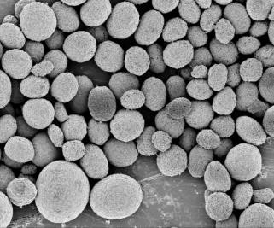
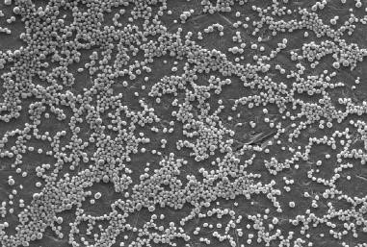

Company information
Evonik is one of the world leaders in specialty chemicals. The company is active in more than 100 countries around the world and generated sales of €13.1 billion and an operating profit (adjusted EBITDA) of €2.15 billion in 2019. Evonik goes far beyond chemistry to create innovative, profitable and sustainable solutions for customers. More than 32,000 employees work together for a common purpose: We want to improve life, day by day.

About Resource Efficiency
The Resource Efficiency segment is led by Evonik Resource Efficiency GmbH and produces high performance materials and specialty additives for environmentally friendly as well as energy-efficient systems to the automotive, paints & coatings, adhesives, construction, and many other industries. This segment employed about 10,000 employees, and generated sales of around €5.7 billion in 2019 from continuing operations.

Disclaimer
In so far as forecasts or expectations are expressed in this press release or where our statements concern the future, these forecasts, expectations or statements may involve known or unknown risks and uncertainties. Actual results or developments may vary, depending on changes in the operating environment. Neither Evonik Industries AG nor its group companies assume an obligation to update the forecasts, expectations or statements contained in this release.

