26.06.2020

Contact specialized press
Thomas Lange
Phone +49 201 173-3050
thomas.lange2@evonik.com

Evonik Resource Efficiency GmbH
Rellinghauser Straße 1-11
45128 Essen
Phone +49 201 177-01
Fax +49 201 177-3475
www.evonik.com

Supervisory Board
Dr. Harald Schwager, Chairman

Executive Board
Dr. Claus Rettig, Chairman
Andreas Fischer,
Simone Hildmann,
Alexandra Schwarz

Registered Office: Essen
Register Court: Essen Local Court
Commercial Registry B 25783
VAT ID no. DE 815528487

Virtual Formulation Assistant COATINO® officially launched

- AI-supported additive recommendations
- Voice control for more flexible working
- Guiding formulations are calculated individually

After about two years of development, COATINO® leaves the Early Access Phase: The virtual assistant is now available free of charge to the entire paint & coatings industry. At www.coatino.com, paint and coatings formulators can obtain AI-based additive recommendations for countless applications and individual guiding formulations for pigment concentrates. COATINO® can not only be used from any electronic device, but it can also be operated by voice control.

The COATINO® recommendation algorithms rely on both AI-based technology and machine learning principles. Evonik operates a high-throughput equipment at its Essen site in Germany that tests and evaluates up to 120 coating formulations every day. The results of these test series flow into the continuous improvement of COATINO®. In addition, the knowledge of COATINO® is enriched by the decades of experience of the additive experts.

In their search for the optimal additive, formulators can choose from countless settings: More than 200 product properties and effects are available to choose from to obtain tailor-made and weighted recommendations. The number of theoretical property combinations is 10⁷⁰, plus around 1,900 existing guiding formulations. And if no guiding formulation exists yet, COATINO® calculates individual formulations for all types of pigment concentrates based on its constantly growing data pool.

The user has maximum freedom of operation: The digital assistant can even be operated directly in the laboratory by voice command. If unexpected challenges arise, the lab worker can obtain technical information on additives and has both hands free to continue working in parallel.

"It was and is a great challenge to teach COATINO® the technical language of our industry," explains Gaetano Blanda, head of the Coating Additives Business Line. "The language assistants available today simply do not understand our common technical vocabulary. And they certainly don't have any expertise in coating additives.”

Oliver Kröhl, project manager of the COATINO® development team, adds: "We had to implement both the necessary language processing and additive know-how nearly from scratch."

A decisive factor in the development of COATINO® was the creation of maximum transparency for the customer. The recommended products can be dynamically compared with each other, so that the customer can grasp the differences in a few seconds and thus make their decision. A total of almost 300 products are available to choose from, including defoamers, dispersing additives, and matting agents. COATINO® sends out all technical, regulatory, and safety data sheets conveniently via the watch list if required.

COATINO® is unique worldwide and was developed by Evonik in cooperation with a leading German supplier of Big Data and AI solutions. COATINO® is continuously being expanded with new functions and even more comprehensive formulation calculations. The next milestone is already in sight: Evonik is currently researching its own smart speaker so that formulators worldwide can access the digital assistant even more flexibly in the future.

With COATINO®, Coating Additives is doing its part to deliver on Evonik's new performance promise: Leading beyond Chemistry. With its digital solutions, the Business Line demonstrates how innovations can go far beyond the actual product portfolio.

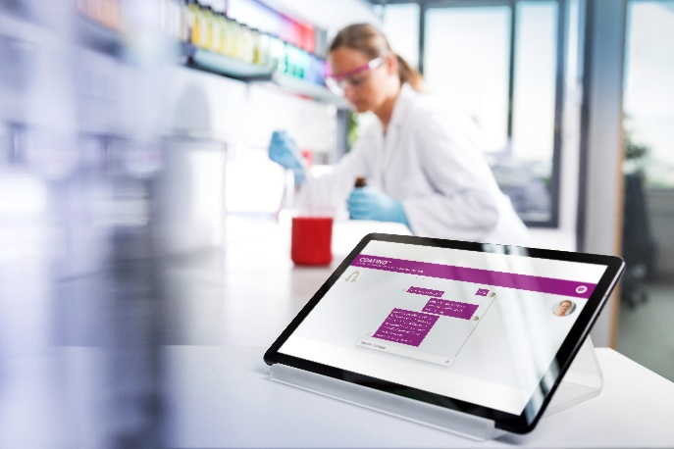
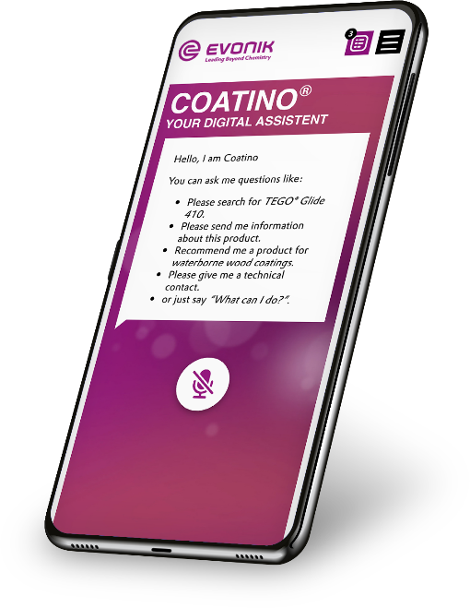
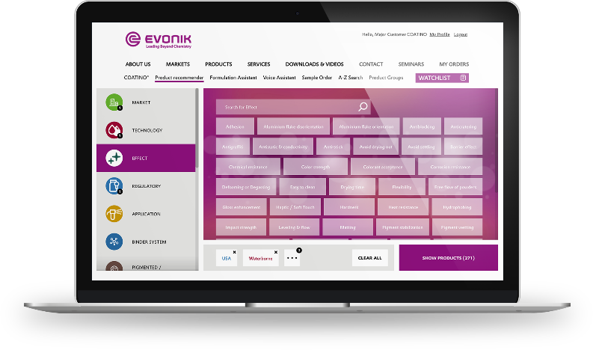

Company information
Evonik is one of the world leaders in specialty chemicals. The company is active in more than 100 countries around the world and generated sales of €13.1 billion and an operating profit (adjusted EBITDA) of €2.15 billion in 2019. Evonik goes far beyond chemistry to create innovative, profitable and sustainable solutions for customers. More than 32,000 employees work together for a common purpose: We want to improve life, day by day.

About Resource Efficiency
The Resource Efficiency segment is led by Evonik Resource Efficiency GmbH and produces high performance materials and specialty additives for environmentally friendly as well as energy-efficient systems to the automotive, paints & coatings, adhesives, construction, and many other industries. This segment employed about 10,000 employees, and generated sales of around €5.7 billion in 2019 from continuing operations.

Disclaimer
In so far as forecasts or expectations are expressed in this press release or where our statements concern the future, these forecasts, expectations or statements may involve known or unknown risks and uncertainties. Actual results or developments may vary, depending on changes in the operating environment. Neither Evonik Industries AG nor its group companies assume an obligation to update the forecasts, expectations or statements contained in this release.

