01.09.2020

Contact specialized press
Thomas Lange
Phone +49 201 173-3050
thomas.lange2@evonik.com

Evonik Industries AG
Rellinghauser Straße 1-11
45128 Essen
Phone +49 201 177-01
Fax +49 201 177-3475
www.evonik.com

Supervisory Board
Bernd Tönjes, Chairman

Executive Board
Christian Kullmann, Chairman
Dr. Harald Schwager, Deputy Chairman
Thomas Wessel
Ute Wolf

Registered Office: Essen
Register Court: Essen Local Court
Commercial Registry B 19474
VAT ID no. DE 811160003
Superior performance without side effects? This defoamer makes it happen!

- Unique combination of strength and compatibility
- Suitable for food packaging
- Good shear resistance and long-lasting effectiveness

There is usually one iron rule with regards to the development of defoamers for paints and coatings: The stronger the defoaming strength, the higher the incompatibility – and therefore the risk of surface defects such as craters.

This relationship between effectiveness and compatibility is linear for defoamers, turning new product development into a balancing act. The question must always be addressed: Which is more important – effectiveness or compatibility? Increasing one sacrifices the other, which is why the use of any defoamer needs to be carefully assessed.

But with knowledge and new insights, even seemingly rigid rules can be overcome – and that’s exactly what Evonik’s Coating Additives Business Line has done. The novel defoamer TEGO® Foamex 852 provides a unique combination of effectiveness and compatibility, offered by no other product on the market. This new, patent-pending technology offers formulators a new level of freedom: You’ve achieved the desired compatibility, but are you still experiencing excessive foaming? TEGO® Foamex 852 provides the critical additional defoaming strength you need – and remains just as compatible.

The new defoamer was specifically developed for printing ink application, and can be used to successfully meet Swiss A, FDA and China GB guidelines. TEGO® Foamex 852 is a siloxane-based defoamer for waterborne formulations, is 100 % active and thereby also solvent-free. Further product benefits include: excellent shear stability and long-term effectiveness, which is particularly relevant for long print runs or if the printing ink must be stored for long periods. Processing is also simple and flexible: The defoamer can be added at any stage of the printing ink manufacturing process.

Coating Additives is constantly working on expanding its existing portfolio and is already researching additional defoamers based on the new technology.

You can find technical, regulatory and safety data sheets on TEGO® Foamex 852 at www.coating-additives.com

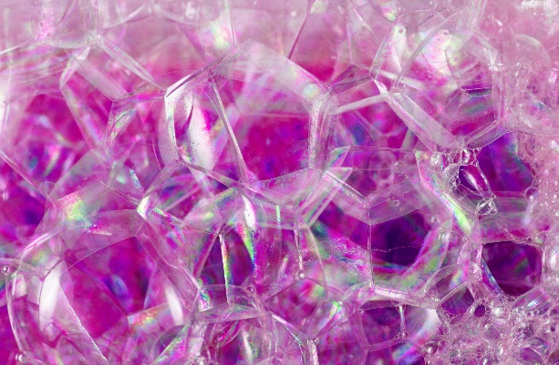

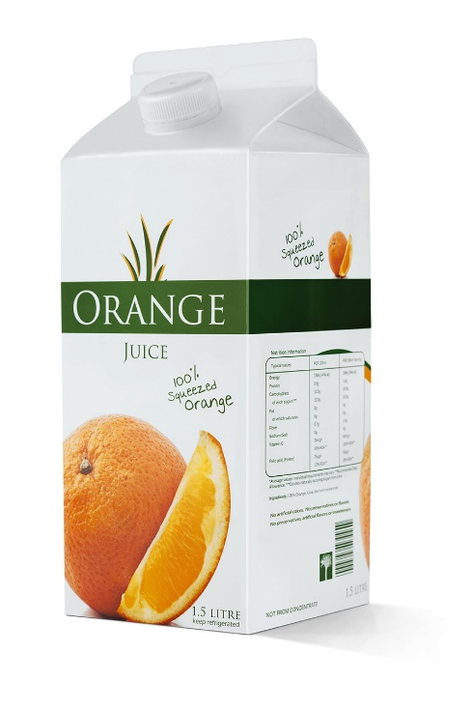

Company information
Evonik is one of the world leaders in specialty chemicals. The company is active in more than 100 countries around the world and generated sales of €13.1 billion and an operating profit (adjusted EBITDA) of €2.15 billion in 2019. Evonik goes far beyond chemistry to create innovative, profitable and sustainable solutions for customers. More than 32,000 employees work together for a common purpose: We want to improve life, day by day.

Disclaimer
In so far as forecasts or expectations are expressed in this press release or where our statements concern the future, these forecasts, expectations or statements may involve known or unknown risks and uncertainties. Actual results or developments may vary, depending on changes in the operating environment. Neither Evonik Industries AG nor its group companies assume an obligation to update the forecasts, expectations or statements contained in this release.

