February 22, 2019

Specialized Press Contact
Thomas Lange
Coating Additives
Phone +49 201 173-3050
thomas.lange2@evonik.com

Evonik Resource Efficiency GmbH
Rellinghauser Straße 1-11
45128 Essen
Phone +49 201 177-01
Fax +49 201 177-3475
www.evonik.com

Supervisory Board
Dr. Harald Schwager, Chairman

Executive Board
Dr. Claus Rettig, Chairman
Dr. Johannes Ohmer,
Simone Hildmann,
Alexandra Schwarz

Registered Office: Essen
Register Court: Essen Local Court
Commercial Registry B 25783
VAT ID no. DE 815528487
ACEMATT® 3400 – New matting agent with high transparency and soft-touch properties
ACEMATT® 3400 is the new matting agent in the ACEMATT® product family from Evonik Resource Efficiency GmbH, specially developed for high-transparency clear coatings and soft-touch coatings with smooth surfaces.

ACEMATT® 3400 is a surface-treated, thermal silica with medium-particle size of 7.5 µm. The improved grind performance results in a smooth surface finish with outstanding optical and haptic properties.

This highly efficient silica is intended for use in clear coatings and water- and solvent-based coatings. Typical application fields include wood coatings, plastics, and automotive coatings. In addition, this new type of matting agent can be used in high-solids and low-VOC formulations.

In regards to rheology, the special after-treatment of ACEMATT® 3300 and ACEMATT® 3400 prevents the adsorption of associative thickeners in water-based systems. Likewise, when formulated with particular polyurethane binders, it can also improve the soft-touch feel.

ACEMATT® 3400 can be easily incorporated into the formulation; no high shear forces are needed, thus, the bead mill can be skipped. Furthermore, ACEMATT® 3400 can be added to the coating formulation at the end of the process, allowing for a post-adjustment of the gloss level.

ACEMATT® matting agents are high-performance silica developed for gloss reduction in a vast range of applications in the paints and coatings industry.

Our best-in-class recommendations for high-quality coatings with excellent transparency are the family of thermal silica ACEMATT® TS 100, ACEMATT® 3300, and ACEMATT® 3400.

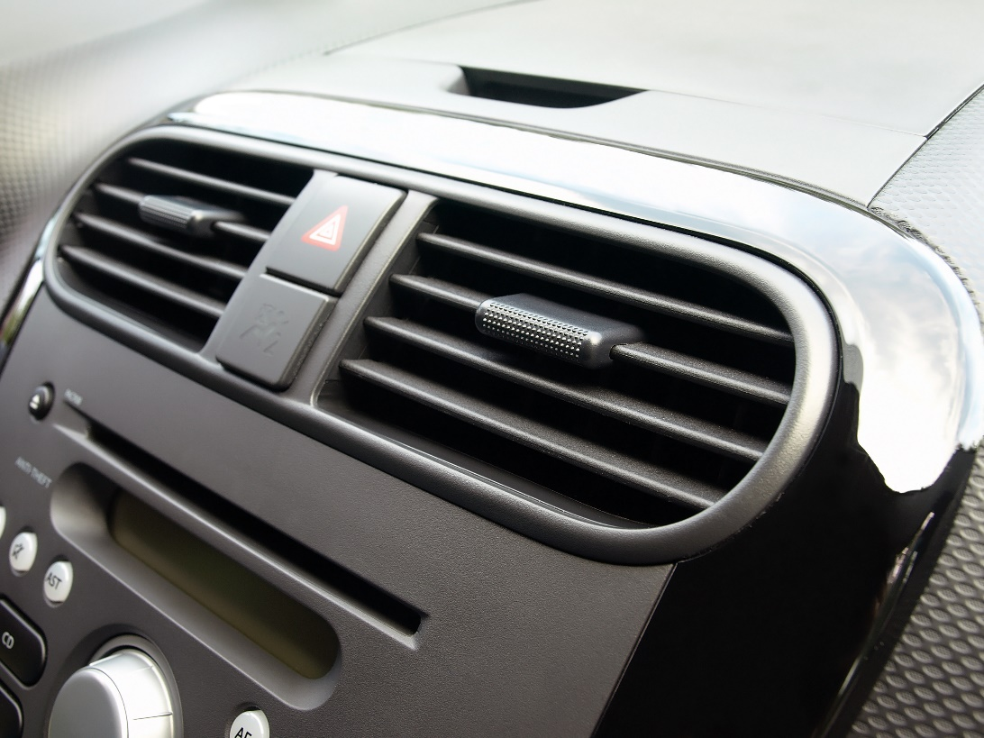
Picture: Soft-touch Coatings

Please visit us at the European Coatings Show, March 19 – 21, 2019 in Nuremberg: Hall 7A, Booth 323.

About Evonik
Evonik is one of the world leaders in specialty chemicals. The focus on more specialty businesses, customer-orientated innovative prowess and a trustful and performance-oriented corporate culture form the heart of Evonik’s corporate strategy. They are the lever for profitable growth and a sustained increase in the value of the company. Evonik benefits specifically from its customer proximity and leading market positions. Evonik is active in over 100 countries around the world with more than 36,000 employees. In fiscal 2017, the enterprise generated sales of €14.4 billion and an operating profit (adjusted EBITDA) of €2.36 billion.

About Resource Efficiency
The Resource Efficiency segment is led by Evonik Resource Efficiency GmbH and produces high performance materials and specialty additives for environmentally friendly as well as energy-efficient systems to the automotive, paints & coatings, adhesives, construction, and many other industries. This segment employed about 10,000 employees, and generated sales of around €5.4 billion in 2017.

Disclaimer
In so far as forecasts or expectations are expressed in this press release or where our statements concern the future, these forecasts, expectations or statements may involve known or unknown risks and uncertainties. Actual results or developments may vary, depending on changes in the operating environment. Neither Evonik Industries AG nor its group companies assume an obligation to update the forecasts, expectations or statements contained in this release.

