March 11, 2019

Contact specialized press
Thomas Lange
Coating Additives
Phone +49 201 173-3050
thomas.lange2@evonik.com

Evonik Resource Efficiency GmbH
Rellinghauser Straße 1-11
45128 Essen
Phone +49 201 177-01
Fax +49 201 177-3475
www.evonik.com

Supervisory Board
Dr. Harald Schwager, Chairman

Executive Board
Dr. Claus Rettig, Chairman
Dr. Johannes Ohmer,
Simone Hildmann,
Alexandra Schwarz

Registered Office: Essen
Register Court: Essen Local Court
Commercial Registry B 25783
VAT ID no. DE 815528487
Improved Recoatability: TEGO® Glide 496

The new TEGO® Glide 496 contributes to perfect surfaces and high-quality appearance of coatings without compromising recoatability and compatibility.

Producers of solvent-based wood coatings (used in kitchen cabinets and furniture) often experience challenges with traditional glide additives that provide good haptic (feel/touch) properties that are not recoatable - and vice versa.

Evonik, Business Line Coating Additives, has developed TEGO® Glide 496 to overcome that challenge!

“We received customer feedback over the past years that recoatability is a remaining challenge in many coating formulations and therefore we decided to enlarge our already existing TEGO® Glide portfolio” says Alexander Kehl, Market Segment Manager for Decorative Coatings and Printing Inks.

Application work has shown that the new TEGO® Glide 496 is suitable for both solvent- and water-based formulations, has excellent compatibility, and demonstrates scratch-resistance improvement in various systems. Furthermore, the additive is globally registered and complies with various food contact regulations.

Besides wood lacquers, the coatings industry has a growing interest for such a new additive in plastics, industrial, and transportation coatings as well as printing inks.

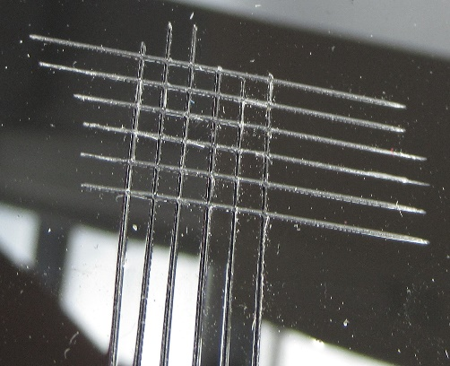
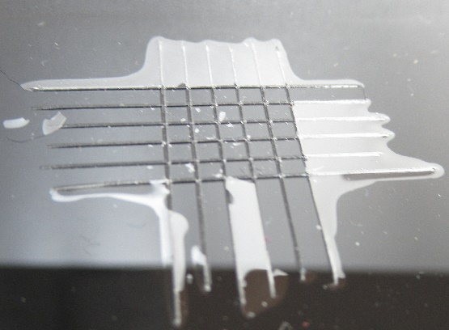
Picture 1: Benchmark Picture 2: TEGO® Glide 496

Please visit us at the European Coatings Show, March 19 – 21, 2019 in Nuremberg: Hall 7A, Booth 323.

For more information please visit our website
www.coating-additives.com

Company information
Evonik is one of the world leaders in specialty chemicals. The focus on more specialty businesses, customer-oriented innovative prowess and a trustful and performance-oriented corporate culture form the heart of Evonik’s corporate strategy. They are the lever for profitable growth and a sustained increase in the value of the company. Evonik benefits specifically from its customer proximity and leading market positions. Evonik is active in over 100 countries around the world with more than 36,000 employees. In fiscal 2018, the enterprise generated sales of €15 billion and an operating profit (adjusted EBITDA) of €2.6 billion.

About Resource Efficiency
The Resource Efficiency segment is led by Evonik Resource Efficiency GmbH and produces high performance materials and specialty additives for environmentally friendly as well as energy-efficient systems to the automotive, paints & coatings, adhesives, construction, and many other industries. This segment employed about 10,000 employees, and generated sales of around €5.7 billion in 2018.

Disclaimer
In so far as forecasts or expectations are expressed in this press release or where our statements concern the future, these forecasts, expectations or statements may involve known or unknown risks and uncertainties. Actual results or developments may vary, depending on changes in the operating environment. Neither Evonik Industries AG nor its group companies assume an obligation to update the forecasts, expectations or statements contained in this release.

