31.10.2019

Contact specialized press
Thomas Lange
Phone +49 201 173-3050
thomas.lange2@evonik.com

Evonik Resource Efficiency GmbH
Rellinghauser Straße 1-11
45128 Essen
Phone +49 201 177-01
Fax +49 201 177-3475
www.evonik.com

Supervisory Board
Dr. Harald Schwager, Chairman

Executive Board
Dr. Claus Rettig, Chairman
Andreas Fischer,
Simone Hildmann,
Alexandra Schwarz

Registered Office: Essen
Register Court: Essen Local Court
Commercial Registry B 25783
VAT ID no. DE 815528487
High Performance Despite Low Silicone Content: SILIKOFTAL® HTL 1 for Cookware

- Good balance of performance and cost-effectiveness
- New silicone resin is suitable for food contact

The new silicone polyester resin SILIKOFTAL® HTL 1 from Evonik Resource Efficiency creates the ideal balance of performance and cost-effectiveness: With a silicone content of just 10%, it provides reliable and long-lasting protection for cookware such as pots and pans. Not only is the solvent-based resin resistant to extreme heat, it also offers a range of further benefits. For instance, in addition to excellent adhesion to various metals such as stainless steel and aluminum, SILIKOFTAL® HTL 1 also offers good post-formation after coating.

The new product, which Evonik is showcasing for the first time at China Coat in November, is suitable for food contact when used in external coatings. Thanks to its unique property profile, it is suitable for a broad range of applications: It can be used anywhere stoving coatings are used. SILIKOFTAL® HTL 1 is also free from aromatic and chlorinated solvents.

Its versatility for all types of applications is also displayed in other areas: Easy pigment incorporation means that colorful and dark coatings are equally possible – as well as gloss finishes. And these also enjoy long-lasting protection. Coatings based on SILIKOFTAL® HTL 1 are, of course, dishwasher safe. The same applies to coatings based on all of Evonik’s other silicone polyester resins.

This launch further extends Evonik’s existing portfolio of silicone polyester resins, offering precisely the right solution for every requirement. In addition to products offering even greater performance, this portfolio also includes waterborne silicone polyester resins.

“We are constantly working on developing new solutions for our customers,” says Maximilian Morin, Head of the Industrial Coatings market segment. “The new SILIKOFTAL® HTL 1 demonstrates that technical requirements and economic demands don’t need to be mutually exclusively.”

You can find regulatory, technical and safety data sheets on SILIKOFTAL® HTL 1 at www.coating-additives.com.

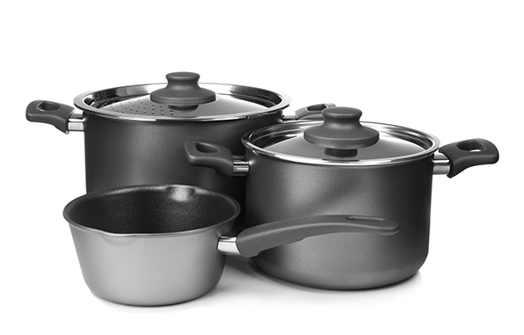

Company information
Evonik is one of the world leaders in specialty chemicals. The focus on more specialty businesses, customer-oriented innovative prowess and a trustful and performance-oriented corporate culture form the heart of Evonik’s corporate strategy. They are the lever for profitable growth and a sustained increase in the value of the company. Evonik benefits specifically from its customer proximity and leading market positions. Evonik is active in over 100 countries around the world. In fiscal 2018, the enterprise with more than 32,000 employees generated sales of €13.3 billion and an operating profit (adjusted EBITDA) of €2.15 billion from continuing operations.

About Resource Efficiency
The Resource Efficiency segment is led by Evonik Resource Efficiency GmbH and produces high performance materials and specialty additives for environmentally friendly as well as energy-efficient systems to the automotive, paints & coatings, adhesives, construction, and many other industries. This segment employed about 10,000 employees, and generated sales of around €5.5 billion in 2018 from continuing operations.

Disclaimer
In so far as forecasts or expectations are expressed in this press release or where our statements concern the future, these forecasts, expectations or statements may involve known or unknown risks and uncertainties. Actual results or developments may vary, depending on changes in the operating environment. Neither Evonik Industries AG nor its group companies assume an obligation to update the forecasts, expectations or statements contained in this release.

