19.03.2020

Contact specialized press
Thomas Lange
Phone +49 201 173-3050
thomas.lange2@evonik.com

Evonik Resource Efficiency GmbH
Rellinghauser Straße 1-11
45128 Essen
Phone +49 201 177-01
Fax +49 201 177-3475
www.evonik.com

Supervisory Board
Dr. Harald Schwager, Chairman

Executive Board
Dr. Claus Rettig, Chairman
Andreas Fischer,
Simone Hildmann,
Alexandra Schwarz

Registered Office: Essen
Register Court: Essen Local Court
Commercial Registry B 25783
VAT ID no. DE 815528487
From Good Comes Better: Low-VOC Version of SURFYNOL® 104 Now Available

- No compromise on performance
- Better labeling, easier to handle

What could be better than a high-performance multi-functional additive? The same additive but without VOCs! Evonik’s Coating Additives business line now presents the next generation of its customer favorite: SURFYNOL® 104 Z. There aren’t many applications that don’t use the additive to improve both the formulation and the finished coating. In automotive or industrial coatings, coatings for plastic or wood, or printing inks – SURFYNOL® 104 has long been one of the most well-known and successful additives in the global paints and coatings industry.

The new generation additive is just as effective as its predecessor with one crucial benefit: It contains virtually no VOCs (depending on regional guidelines and measuring method). This significant advantage means that the product requires minimal special labeling and is therefore easier to use, process, and store. SURFYNOL® 104 Z is a silicone-free additive, developed in response to the increasingly tight regulatory requirements.

As with the previous generation, the new additive is also suitable for applications requiring food contact compliance; it meets FDA and Swiss A requirements. Besides the lower VOC content and improved product labeling, SURFYNOL® 104 Z still offers the benefits it is known for. It defoams, it wets, it improves leveling. And above all, it has no negative impact on the formulation. As required, the product can be used at any stage of the formulation process: in the mill base, the let-down, in production or during subsequent quality control.

SURFYNOL® 104 Z is a multi-functional gemini surfactant, which performs a balancing act between dynamic wetting and molecular defoaming. It contains 50 % active substance. The new additive is HAPs-free and helps formulators to transition more easily from solventborne to waterborne systems.

You can find technical, regulatory and safety data sheets on SURFYNOL® 104 Z at www.coating-additives.com.

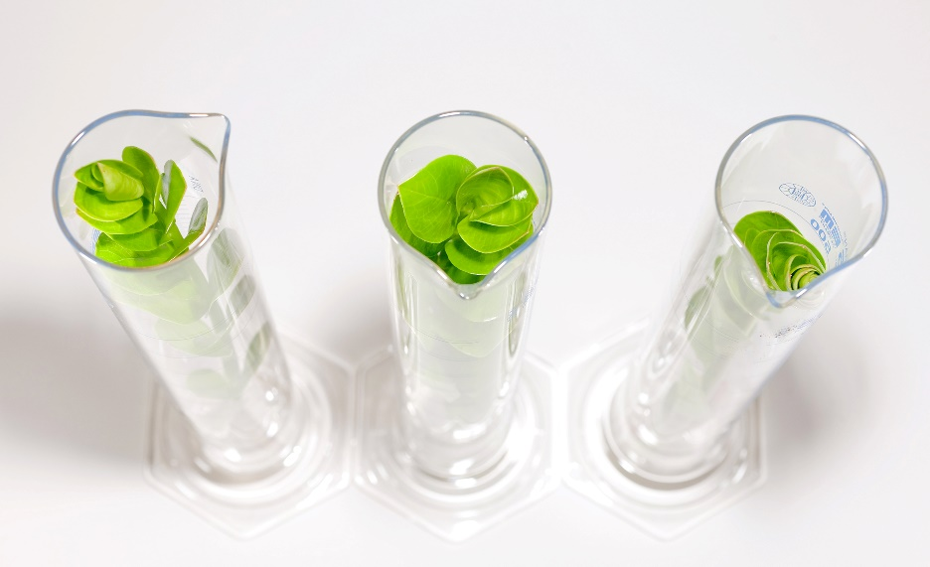

Company information
Evonik is one of the world leaders in specialty chemicals. The company is active in more than 100 countries around the world and generated sales of €13.1 billion and an operating profit (adjusted EBITDA) of €2.15 billion in 2019. Evonik goes far beyond chemistry to create innovative, profitable and sustainable solutions for customers. More than 32,000 employees work together for a common purpose: We want to improve life, day by day.

About Resource Efficiency
The Resource Efficiency segment is led by Evonik Resource Efficiency GmbH and produces high performance materials and specialty additives for environmentally friendly as well as energy-efficient systems to the automotive, paints & coatings, adhesives, construction, and many other industries. This segment employed about 10,000 employees, and generated sales of around €5.7 billion in 2019 from continuing operations.

Disclaimer
In so far as forecasts or expectations are expressed in this press release or where our statements concern the future, these forecasts, expectations or statements may involve known or unknown risks and uncertainties. Actual results or developments may vary, depending on changes in the operating environment. Neither Evonik Industries AG nor its group companies assume an obligation to update the forecasts, expectations or statements contained in this release.

