March 31, 2017

Specialized Press Contact
Thomas Lange
Coating Additives
Phone +49 201 173-3050
thomas.lange2@evonik.com

Evonik Resource Efficiency GmbH
Rellinghauser Straße 1-11
45128 Essen
Phone +49 201 177-01
Fax +49 201 177-3475
www.evonik.com

Supervisory Board
Dr. Ralph Sven Kaufmann, Chairman

Executive Board
Dr. Claus Rettig, Chairman
Dr. Johannes Ohmer,
Simone Hildmann,
Alexandra Schwarz

Registered Office: Essen
Register Court: Essen Local Court
Commercial Registry B 25783
VAT ID no. DE 815528487
New specialty additives for safe food packaging

Evonik offers a range of high-performance additives designed to meet the more stringent global regulations effecting customers who manufacture and print materials for food packaging. The Resource Efficiency Segment is introducing a number of products at the European Coatings Show that offers broad food contact compliances combined with exceptional performance, including Airase® 5355, Airase® 5655, and Airase® 4655 defoamers, as well as a new wetting agent, Surfynol® 355 surfactant. These products were originally developed by the former Performance Materials Division of Air Products, which the Essen, Germany based company recently acquired.

Airase® 5355 and Airase® 5655 defoamers are siloxane-based additives designed to control and quickly eliminate foam without generating surface defects in water-based pigment grinds, inks, overprint varnishes, adhesives and coatings. While the emphasis during the Airase® 5355 defoamer development process was on maximizing antifoaming effects, Airase® 5655 defoamer was designed to focus on compatibility with other ingredients. A further option included in this new product portfolio to help formulators meet food contact compliances is the relatively compatible, oil-based Airase® 4655 defoamer. All three products were developed specifically for use in food packaging applications.

They do not contain added mineral oils, hazardous air pollutants (HAPs) or alkyl phenol ethoxylates (APEs), and they are suitable for low-VOC formulations.

Surfynol® 355 surfactant is a proprietary wetting agent designed to provide dynamic wetting without generating excess foam in water-based pigment dispersions, inks, overprint varnishes, adhesives and coatings. Thanks to its unique chemical properties, this product yields optimum results, even on difficult-to-wet substrates such as lithographic inks and silicone release liners, without contributing to excessive foam formation.

All four additives have two characteristics in common: broad applicability and exceptional performance in many different food contact end-use applications. And one thing is certain: all can be used in compliance with the complex mix of regional and national regulatory requirements in numerous countries, including the U.S. (FDA 21CFR 175.105, 176.170, 176.180, etc.), Switzerland (Swiss Ordinance, Annex 10, Part A), Japan (not on the negative list for printing inks), and China (GB9685-2016). Other regulations may also apply, depending on the application. Surfynol® 355 surfactant and Airase® 4655 defoamer, for instance, meet the stipulations of the European Union plastics directive (PIM EU 10/2011) and the recommendations of the German Federal Institute for Risk Assessment (BfR, Recommendation XIV & XXXVI). This ensures that packages processed with either these Airase® or Surfynol® food contact compliant products can be used safely throughout the world.

Evonik has launched a dedicated website to make it easy for its customers to learn more about the full portfolio of additives with food contact compliance. All information can be found at
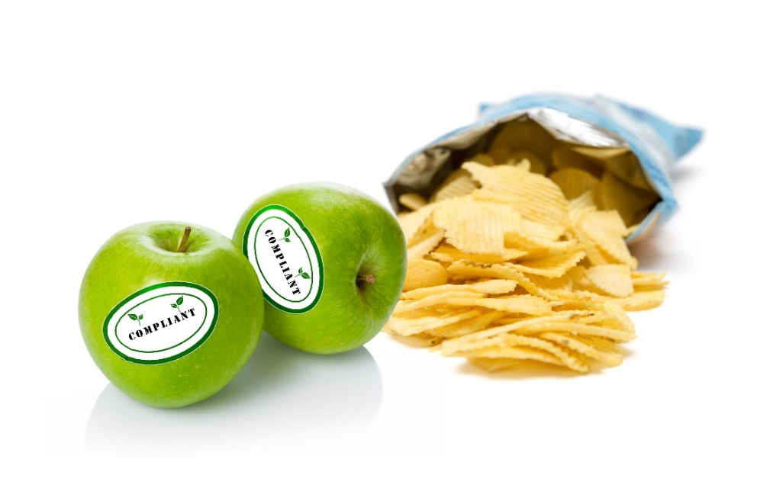
www.evonik.com/food-contact-status.

Caption:
Airase® 5355, Airase® 5655, and Airase® 4655 defoamers, as well as the new wetting agent, Surfynol® 355 surfactant offer broad food contact compliances combined with exceptional performance.
Visit us at the European Coatings Show in Nuremberg,
April 4 – 6, 2017, hall 7A, booth 323.

Company information
Evonik, the creative industrial group from Germany, is one of the world leaders in specialty chemicals. Profitable growth and a sustained increase in the value of the company form the heart of Evonik’s corporate strategy. Evonik benefits specifically from its innovative prowess and integrated technology platforms. Evonik is active in over 100 countries around the world with more than 35,000 employees. In fiscal 2016 the enterprise generated sales of around €12,7 billion and an operating profit (adjusted EBITDA) of about €2.165 billion.

About Resource Efficiency
The Resource Efficiency segment is led by Evonik Resource Efficiency GmbH and supplies high performance materials for environmentally friendly as well as energy-efficient systems to the automotive, paints & coatings, adhesives, construction, and many other industries. This segment employed about 9,000 employees, and generated sales of around €4.5 billion in 2016.

Disclaimer
In so far as forecasts or expectations are expressed in this press release or where our statements concern the future, these forecasts, expectations or statements may involve known or unknown risks and uncertainties. Actual results or developments may vary, depending on changes in the operating environment. Neither Evonik Industries AG nor its group companies assume an obligation to update the forecasts, expectations or statements contained in this release.

