March 28, 2017

Specialized Press Contact
Thomas Lange
Coating Additives
Phone +49 201 173-3050
thomas.lange2@evonik.com
Evonik Resource Efficiency GmbH
Rellinghauser Straße 1-11
45128 Essen
Germany
Phone +49 201 177-01
Fax +49 201 177-3475
www.evonik.com

Supervisory Board
Dr. Ralph Sven Kaufmann, Chairman

Executive Board
Dr. Claus Rettig, Chairman
Dr. Johannes Ohmer,
Simone Hildmann,
Alexandra Schwarz

Registered Office: Essen
Register Court: Essen Local Court
Commercial Registry B 25783
VAT ID no. DE 815528487
Structurally modified, hydrophilic silica improves the anti-fouling properties of coatings based on cuprous oxide

Structurally modified, hydrophilic AEROSIL® improves the anti-fouling properties and product life of anti-fouling coatings. Customers use the product in formulations with cuprous oxide (Cu₂O) to take advantage of the resulting synergies.

VP 4200 is a development product that, as an active extender with cuprous oxide, exhibits effective anti-fouling properties while lowering the amount of Cu₂O needed in the coating formulation. In terms of product function, the structural modification process significantly increases bulk density, effectively reducing the thickening effect of AEROSIL® and making higher loading capacities possible. Not only does the high solids content help anchor the cuprous oxide — significant reinforcement and durability of the film also helps make the cuprous oxide available for longer periods of time. The product works in spray applications just as before.

When VP 4200 is added at concentrations exceeding 10 percent (relative to the total formulation), effective anti-fouling effects have been demonstrated at much lower concentrations of Cu₂O (roughly 6 percent, also relative to the total formulation). In addition, a novel particle design based on hydrophobic, structurally modified VP 4200 is more effective in formulations than hydrophobically modified versions.

Structurally modified AEROSIL® grades were introduced over 10 years ago as a way of improving scratch resistance and mechanical durability of products in the coatings, adhesives, and sealants industries. The new developments are opening the door to novel applications that represent environmentally sustainable improvements to anti-fouling effects in maritime environments.

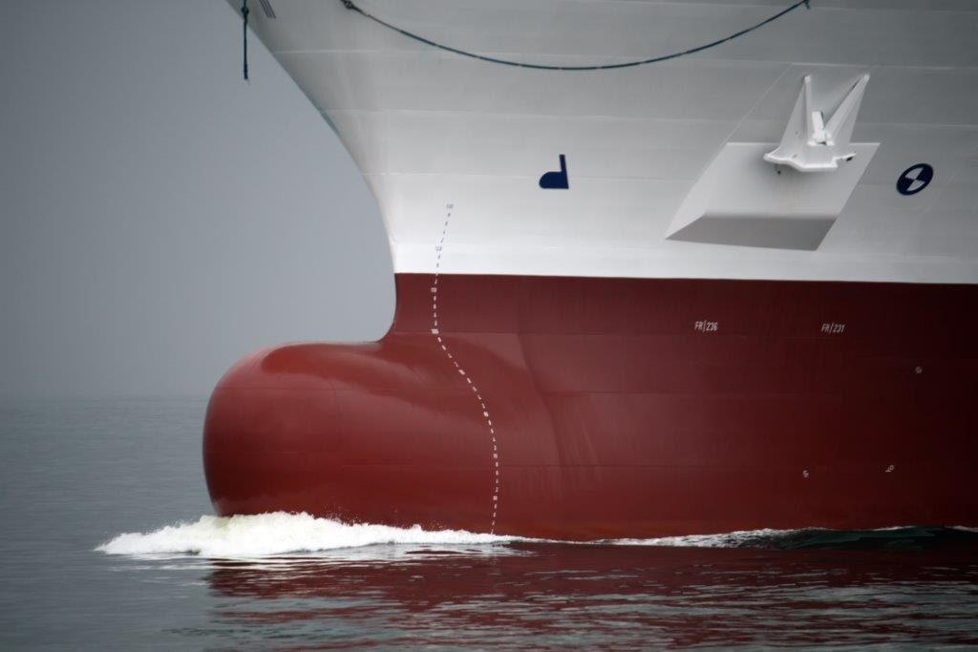
Caption:
The new product, as an active extender with cuprous oxide, exhibits effective anti-fouling properties.

Visit us at the European Coatings Show in Nuremberg,
April 4 – 6, 2017, hall 7A, booth 323.

Company information
Evonik, the creative industrial group from Germany, is one of the world leaders in specialty chemicals. Profitable growth and a sustained increase in the value of the company form the heart of Evonik’s corporate strategy. Evonik benefits specifically from its innovative prowess and integrated technology platforms. Evonik is active in over 100 countries around the world with more than 35,000 employees. In fiscal 2016 the enterprise generated sales of around €12,7 billion and an operating profit (adjusted EBITDA) of about €2.165 billion.

About Resource Efficiency
The Resource Efficiency segment is led by Evonik Resource Efficiency GmbH and supplies high performance materials for environmentally friendly as well as energy-efficient systems to the automotive, paints & coatings, adhesives, construction, and many other industries. This segment employed about 9,000 employees, and generated sales of around €4.5 billion in 2016.

Disclaimer
In so far as forecasts or expectations are expressed in this press release or where our statements concern the future, these forecasts, expectations or statements may involve known or unknown risks and uncertainties. Actual results or developments may vary, depending on changes in the operating environment. Neither Evonik Industries AG nor its group companies assume an obligation to update the forecasts, expectations or statements contained in this release.

