March 7, 2017

Specialized Press Contact
Thomas Lange
Coating Additives
Phone +49 201 173-3050
thomas.lange2@evonik.com
Evonik Resource Efficiency GmbH
Rellinghauser Straße 1-11
45128 Essen
Germany
Phone +49 201 177-01
Fax +49 201 177-3475
www.evonik.com

Supervisory Board
Dr. Ralph Sven Kaufmann, Chairman

Board of Management
Dr. Claus Rettig, Chairman
Dr. Johannes Ohmer,
Simone Hildmann,
Alexandra Schwarz

Registered Office: Essen
Register Court: Essen Local Court
Commercial Registry B 25783
VAT ID no. DE 815528487
Speed circuit for coating formulations shortens development time

With its new, fully automated plant for testing coating formulations, Evonik can accelerate the search for optimal formulations. The high-throughput plant enables the company to systematically test more formulations over the same period of time than before. For Evonik’s customers, this means they can optimize and develop their coating formulations quicker, saving valuable time when launching new products into the market.

The number of combinations of substances for coatings formulations is enormous: Even if only ten hardeners, ten binding agents, ten pigments and ten additives are to be taken into account in the development of a coating formulation, this results in 10⁴ or 10,000 combinations. And this does not even include variations in proportions.

In practice, it is impossible to cover the complete range of possibilities or to test the properties of all combinations and proportions. However, a systematic search for the optimal coating formulation requires exactly that: examination of an enormous range of options. With the set-up of their high-throughput plant, the coatings experts at Evonik have found a solution for this dilemma.

In the first step, the plant dispenses raw materials automatically and formulates them into coatings. In the second step, the substrates are coated with the formulations, dried, and then transported to the test stand. At the test stand, the properties of the formulations are characterized. All steps are carried out automatically according to a precisely defined program that can be reproduced at any time.

The plant consists of 52 elements that are combined in 30 functionalities; each functionality is designed to handle a specific task (for example, to apply a coating formulation to a substrate). The 52 elements are connected by a rail system that goes through all parts of the plant; on the rail systems, containers and substrates are transported via shuttle. In addition, there are 13 robots that carry out various activities such as loading the shuttle or placing coated substrates in the oven.

Within 24 hours, an average of 120 samples can be formulated in the plant. While these are being applied to a substrate and characterized, the experiments for a new project can be initiated.

Thanks to sophisticated technology and software, the HTE plant is extremely reliable and reproducible at any time. It registers any deviations from the target value and saves them. This means that in the case of conspicuous results, it is easy to check if there have been any irregularities in the work processes.

With up to 600 parameters, 40 different work steps can be defined precisely in the HTE plant. This enables Evonik to freely combine the individual steps in a workflow and to incorporate the diverse requirements of the customers.

Visit us at the European Coatings Show in Nuremberg from April 4 to 6, 2017, in Hall 7A, Stand 323

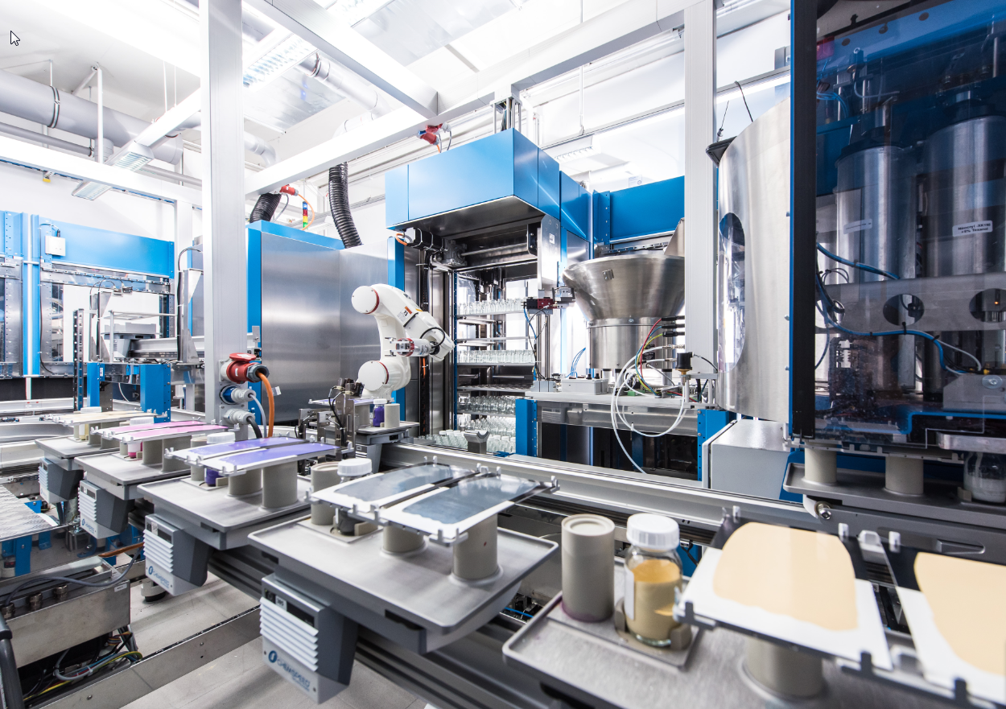

Caption: The new high-throughput plant in Essen can formulate and test up to 120 samples daily.

Company information
Evonik, the creative industrial group from Germany, is one of the world leaders in specialty chemicals. Profitable growth and a sustained increase in the value of the company form the heart of Evonik’s corporate strategy. Evonik benefits specifically from its innovative prowess and integrated technology platforms. Evonik is active in over 100 countries around the world with more than 35,000 employees. In fiscal 2016 the enterprise generated sales of around €12,7 billion and an operating profit (adjusted EBITDA) of about €2.165 billion.

About Resource Efficiency
The Resource Efficiency segment is led by Evonik Resource Efficiency GmbH and supplies high performance materials for environmentally friendly as well as energy-efficient systems to the automotive, paints & coatings, adhesives, construction, and many other industries. This segment employed about 9,000 employees, and generated sales of around €4.5 billion in 2016.

Disclaimer
In so far as forecasts or expectations are expressed in this press release or where our statements concern the future, these forecasts, expectations or statements may involve known or unknown risks and uncertainties. Actual results or developments may vary, depending on changes in the operating environment. Neither Evonik Industries AG nor its group companies assume an obligation to update the forecasts, expectations or statements contained in this release.

