February 6th, 2017

Specialized press contact
Thomas Lange
Coating Additives
Phone +49 201 173-3050
thomas.lange2@evonik.com

Regional press contact
Constanze Buckow-Wallén
Communication Europe
Phone +49 618159-12566
constanze.buckow-wallen@evonik.com

Evonik Resource Efficiency GmbH
Rellinghauser Straße 1-11
45128 Essen
Phone +49 201 177-01
Fax +49 201 177-3475
www.evonik.com

Supervisory Board
Dr. Ralph Sven Kaufmann, Chairman

Executive Board
Dr. Claus Rettig, Chairman
Dr. Johannes Ohmer,
Simone Hildmann,
Alexandra Schwarz

Registered Office: Essen
Register Court: Essen Local Court
Commercial Registry B 25783
VAT ID no. DE 815528487
Evonik opens coatings laboratory in Turkey

Evonik opened a new Coating Additives laboratory at its Tuzla (Istanbul) site on January 31, 2017. The state-of-the-art laboratory, which also includes a customer service center, will support customers with the development of innovative surface coatings in Turkey and throughout the Middle East.

The application technology laboratory features top-of-the-line equipment for processing customer requests for a wide range of coatings and printing ink applications. This allows the lab staff to effectively formulate, apply, and test a variety of coatings and printing inks in water-based, solvent-based, or radiation-curing formats. The modern laboratory equipment also includes a spray booth and a climatic chamber.

“The new laboratory strengthens our presence in the region,” emphasizes Gaetano Blanda, the head of the Coating Additives business line. “It enhances our market proximity and enables us to provide our customers with technical service and product solutions for the development of new formulations even faster.”

The new laboratory and the adjacent customer service center has created two new jobs and is staffed by five employees total.

From its Tuzla site east of Istanbul, Evonik Ticaret Ltd. manages the distribution for the Turkish domestic market and exports to adjacent growth markets with a staff of fifty employees. Evonik Ticaret will celebrate its 30th anniversary in Turkey in August 2017. The opening of the new laboratory is just another milestone of the Evonik growth strategy for Turkey.

Evonik’s most important products in Turkey include monomers, amino acids, cyanides, silicas and superabsorbents. The Group also holds 51% of shares in Egesil Kimya Sanayi & Ticaret, a joint venture based in Adapazari (near Istanbul) for the production of silica.

Evonik recently completed the acquisition of the Performance Materials Division of Air Products, making the Group a leading provider of additives for the coatings industry. The company's product portfolio includes over 500 products with a broad assortment comprised of additives, co-binders, matting agents, silicas, specialty resins, and nanoresins. Among its globally known brand names are AEROSIL®, SURFYNOL®, and TEGO®.

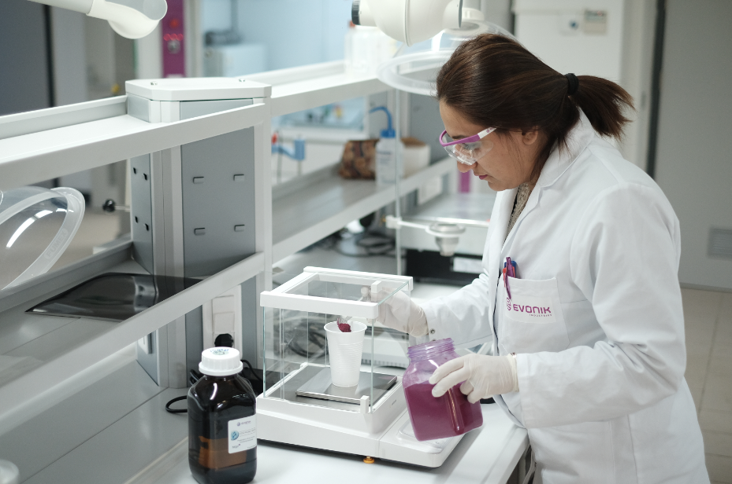
Visit us at the European Coatings Show in Nuremberg in Hall 7A, Booth 323, from April 4 to 6, 2017.

Company information
Evonik, the creative industrial group from Germany, is one of the world leaders in specialty chemicals, operating in the Nutrition & Care, Resource Efficiency and Performance Materials segments. The company benefits from its innovative prowess and integrated technology platforms. In 2015 more than 33,500 employees generated sales of around €13.5 billion and an operating profit (adjusted EBITDA) of about €2.47 billion.

About Resource Efficiency
The Resource Efficiency segment is led by Evonik Resource Efficiency GmbH and supplies high performance materials for environmentally friendly as well as energy-efficient systems to the automotive, paints & coatings, adhesives, construction, and many other industries. This segment employed about 8,600 employees, and generated sales of around €4.3 billion in 2015.

Disclaimer
In so far as forecasts or expectations are expressed in this press release or where our statements concern the future, these forecasts, expectations or statements may involve known or unknown risks and uncertainties. Actual results or developments may vary, depending on changes in the operating environment. Neither Evonik Industries AG nor its group companies assume an obligation to update the forecasts, expectations or statements contained in this release.

