December 08, 2016

Contact person specialized press
Thomas Lange
Coating Additives
Phone +49 201 173-3050
thomas.lange2@evonik.com
Evonik Resource Efficiency GmbH
Rellinghauser Straße 1-11
45128 Essen
Phone +49 201 177-01
Fax +49 201 177-3475
www.evonik.com

Supervisory Board
Dr. Ralph Sven Kaufmann, Chairman

Executive Board
Dr. Claus Rettig, Chairman
Dr. Johannes Ohmer,
Simone Hildmann,
Alexandra Schwarz

Registered Office: Essen
Register Court: Essen Local Court
Commercial Registry B 25783
VAT ID no. DE 815528487
Lasting print results for modern packaging designs -
A new slip additive suitable for food contact

TEGO® Glide A 116 is a highly effective slip additive from Evonik for use in solvent-based printing applications. Demands made up on printing ink formulations are high, especially in the packaging market, as they must be high quality, reliable, and in compliance with regulations. Because it is easy to process and is highly compatible with other materials — particularly when used in overprint varnishes — TEGO® Glide A 116 yields outstanding print quality while meeting all legal requirements.

Its outstanding compatibility in color printing systems unique in the market. TEGO® Glide A 116 works especially well in combination with waxes and matting agents, where it lends a perfect finish to the product. It also eliminates sensitivity to scratching and keeps surfaces from sticking together, particularly during the production process.

Food packaging is a particularly important component of the packaging market, and strict regulations help ensure safety in this sensitive area. TEGO® Glide A 116 is in compliance with regulatory demands and legal requirements; a complete listing is available for Switzerland’s Consumer Goods Ordinance (A).

“When designed well, food packaging helps with product placement, provides the customer with information, and, most importantly, protects food,” says Anna-Maria Ickert, director of global marketing for inks & new applications. “TEGO® Glide A 116 yields ideal printing results in an exceptionally wide variety of applications, such as beverage containers, plastic packaging for ice-cream and chocolate, and in labels or films for printing on surfaces. TEGO® Glide A 116 is highly compatible with other materials, produces lasting results in overprint varnishes, and meets regulatory requirements. It’s a highly effective slip additive for all solvent-based end-use applications.”

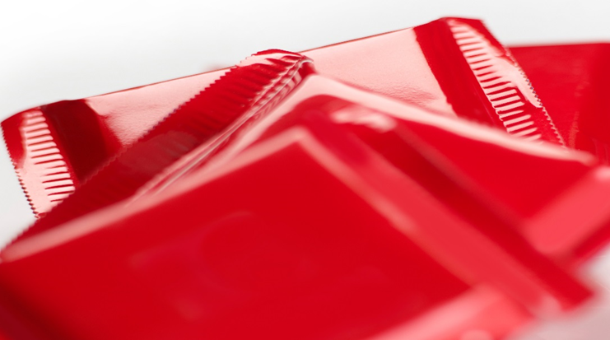
Caption: Plastic packaging

Company information
Evonik, the creative industrial group from Germany, is one of the world leaders in specialty chemicals, operating in the Nutrition & Care, Resource Efficiency and Performance Materials segments. The company benefits from its innovative prowess and integrated technology platforms. In 2015 more than 33,500 employees generated sales of around €13.5 billion and an operating profit (adjusted EBITDA) of about €2.47 billion.

About Resource Efficiency
The Resource Efficiency segment is led by Evonik Resource Efficiency GmbH and supplies high performance materials for environmentally friendly as well as energy-efficient systems to the automotive, paints & coatings, adhesives, construction, and many other industries. This segment employed about 8,600 employees, and generated sales of around €4.3 billion in 2015.

Disclaimer
In so far as forecasts or expectations are expressed in this press release or where our statements concern the future, these forecasts, expectations or statements may involve known or unknown risks and uncertainties. Actual results or developments may vary, depending on changes in the operating environment. Neither Evonik Industries AG nor its group companies assume an obligation to update the forecasts, expectations or statements contained in this release.

