March 24, 2017

Specialized Press Contact
Thomas Lange
Coating Additives
Phone +49 201 173-3050
thomas.lange2@evonik.com
Evonik Resource Efficiency GmbH
Rellinghauser Straße 1-11
45128 Essen
Phone +49 201 177-01
Fax +49 201 177-3475
www.evonik.com

Supervisory Board
Dr. Ralph Sven Kaufmann, Chairman

Executive Board
Dr. Claus Rettig, Chairman
Dr. Johannes Ohmer,
Simone Hildmann,
Alexandra Schwarz

Registered Office: Essen
Register Court: Essen Local Court
Commercial Registry B 25783
VAT ID no. DE 815528487
Evonik launches next generation Grind Aid engineered to meet VOC and regulatory compliances in Coatings and Inks

Evonik offers a range of high-performance additives and its Coatings Additives business will showcase the latest addition to the product line - Carbowet® GA-200 surfactant - at the European Coatings Show, Nuremburg. Carbowet® GA-200 surfactant provides multifunctional benefits in a wide range of aqueous formulations and meets increasing global regulations and EH&S considerations.

Originally developed by the former Performance Materials Division of Air Products, which the Essen, Germany based company recently acquired, Carbowet® GA-200 surfactant is suitable for low-zero VOC, low emission and Ecolabel compliant formulations. In addition, this non-ionic, next generation Grind Aid surfactant offers superior low-foam surfactancy for pigmented systems providing wetting, milling, and compatibilization benefits without the adverse impacts on water sensitivity, foam, or rheology typically found with other surfactants.

The performance characteristics of Carbowet® GA-200 surfactant extend to a wide range of applications and formulations in which the combination of dynamic wetting, compatibilization and stabilization can provide unique benefits.

The Carbowet® GA-200 surfactant is the latest in the line of engineered solutions for the coatings market and its benefits, as well as others are featured in a paper - “Leveraging surfactant Structure-Property Relationships to Address Emerging Needs in Coatings,” by Christine Louis, Evonik Materials Netherlands B.V., The Netherlands and K. Michael Peck, Evonik Corporation, USA – that will be presented on Monday 3rd April in session 5 on Day one of the European Coatings Show Conference 2017.

Visit us at the European Coatings Show in Nuremberg,
April 4 – 6, 2017, hall 7A, booth 323.

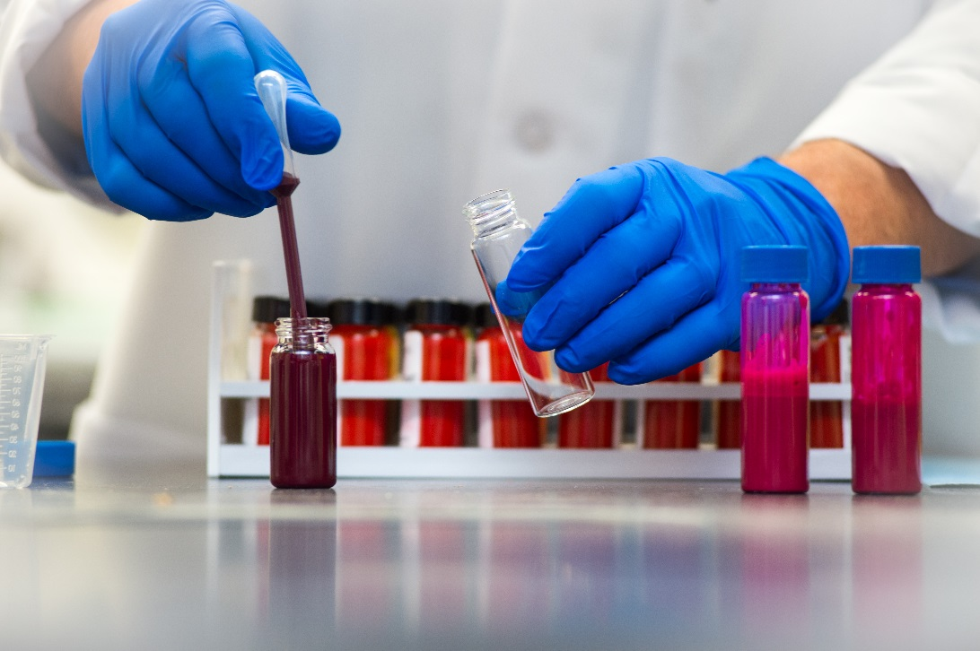
Caption:
Carbowet® GA-200 surfactant provides multifunctional benefits in a wide range of aqueous formulations and meets increasing global regulations and EH&S considerations.

Company information
Evonik, the creative industrial group from Germany, is one of the world leaders in specialty chemicals. Profitable growth and a sustained increase in the value of the company form the heart of Evonik’s corporate strategy. Evonik benefits specifically from its innovative prowess and integrated technology platforms. Evonik is active in over 100 countries around the world with more than 35,000 employees. In fiscal 2016 the enterprise generated sales of around €12,7 billion and an operating profit (adjusted EBITDA) of about €2.165 billion.

About Resource Efficiency
The Resource Efficiency segment is led by Evonik Resource Efficiency GmbH and supplies high performance materials for environmentally friendly as well as energy-efficient systems to the automotive, paints & coatings, adhesives, construction, and many other industries. This segment employed about 9,000 employees, and generated sales of around €4.5 billion in 2016.

Disclaimer
In so far as forecasts or expectations are expressed in this press release or where our statements concern the future, these forecasts, expectations or statements may involve known or unknown risks and uncertainties. Actual results or developments may vary, depending on changes in the operating environment. Neither Evonik Industries AG nor its group companies assume an obligation to update the forecasts, expectations or statements contained in this release.

