March 27, 2017

Specialized Press Contact
Thomas Lange
Coating Additives
Phone +49 201 173 3050
thomas.lange2@evonik.com
Evonik Resource Efficiency GmbH
Rellinghauser Straße 1-11
45128 Essen
Germany
Phone +49 201 177-01
Fax +49 201 177-3475
www.evonik.com

Supervisory Board
Dr. Ralph Sven Kaufmann, Chairman

Executive Board
Dr. Claus Rettig, Chairman
Dr. Johannes Ohmer,
Simone Hildmann,
Alexandra Schwarz

Registered Office: Essen
Register Court: Essen Local Court
Commercial Registry B 25783
VAT ID no. DE 815528487
ALBIDUR® 1223: Long-term flexibility and corrosion protection

With the launch of ALBIDUR® 1223, Evonik has introduced to the market a product that ensures long-term coating flexibility. Used as a co-binder in anti-corrosion paints and coatings, the new product complements formulations based on Evonik’s SILIKOPON® EF and SILIKOPON® ED hybrid resins. By promoting long-term resistance to chemicals and UV light, ALBIDUR® 1223 offers coatings lasting protection against corrosion.

“Anti-corrosion coatings tend to become brittle as they age,” explains Kirstin Schulz, marketing director for industrial coatings. “ALBIDUR® 1223 makes these kinds of coatings more flexible over the long term. Plus, it doesn’t migrate, which keeps the chemical and UV resistance of the coating at a consistently high level.”

ALBIDUR® 1223 does not contain solvents, and it is not subject to labeling requirements. As a result, it is exceptionally easy to handle for shipping and storage. Even though ALBIDUR® 1223 is silicone-free, it is still highly compatible with SILIKOPON® EF and SILIKOPON® ED.

ALBIDUR® 1223 is registered and available worldwide. Because it keeps with the global trend toward NISO (non-isocyanate curing) products, the product also meets regulations already in place in Scandinavia.

More information is available at www.tego.de.

Visit us at the European Coatings Show in Nuremberg,
April 4 – 6, 2017, hall 7A, booth 323.

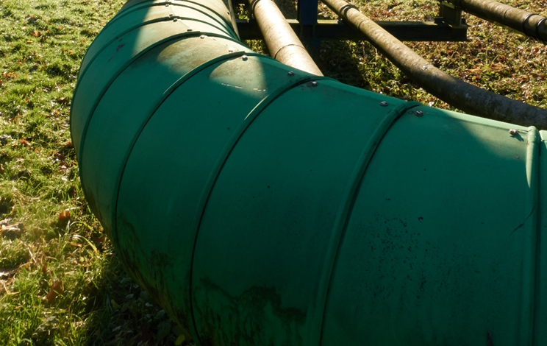
Caption:
With the launch of ALBIDUR® 1223, Evonik has introduced to the market a product that ensures long-term coating flexibility.

Company information
Evonik, the creative industrial group from Germany, is one of the world leaders in specialty chemicals. Profitable growth and a sustained increase in the value of the company form the heart of Evonik’s corporate strategy. Evonik benefits specifically from its innovative prowess and integrated technology platforms. Evonik is active in over 100 countries around the world with more than 35,000 employees. In fiscal 2016 the enterprise generated sales of around €12,7 billion and an operating profit (adjusted EBITDA) of about €2.165 billion.

About Resource Efficiency
The Resource Efficiency Segment is led by Evonik Resource Efficiency GmbH and supplies high performance materials for environmentally friendly as well as energy-efficient systems to the automotive, paints & coatings, adhesives, construction, and many other industries. This segment employed about 9,000 employees, and generated sales of around €4.5 billion in 2016.

Disclaimer
In so far as forecasts or expectations are expressed in this press release or where our statements concern the future, these forecasts, expectations or statements may involve known or unknown risks and uncertainties. Actual results or developments may vary, depending on changes in the operating environment. Neither Evonik Industries AG nor its group companies assume an obligation to update the forecasts, expectations or statements contained in this release.

